02.05 Integer Division and Modulo

Integer Division

There are two new mathematical operations that programming uses quite often.

Consider 20 divided by 7.
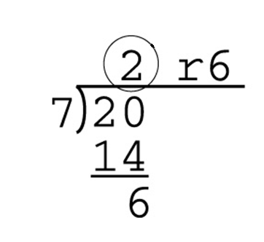

The 2 is the number of times 7 divides into 20 evenly without going over.
This is called integer division. The operator for integer division in Python is two slashes, or //

The above example would be written 20 // 7. Basically 20 //7 is asking “how many times will 7 divide evenly into 20 without going over?”.
The answer is 2.

Try
print(20 // 7)
print(30 // 4) #The answer should be 7. Remember to put
#blanks around the operators.

What would happen with 30 / / 4, which has a blank between the slashes? Try.

Try
result = 100 // 35
print (result)

Try
first_number = 20
second_number = 3
third_number = 30

print (first_number // second_number)
print(first_number // third_number)

Modulo

Now let’s revisit the first math example.

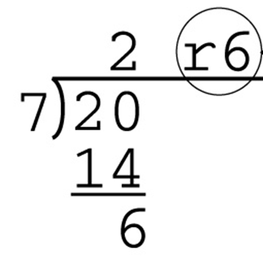

The remainder is 6. Determining the remainder after division is called modulo. The operator for modulo in Python is the percentage, or %.

The above example would be written 20 % 7, which asks “what is the remainder when 7 divides into 20 without going over?”. The result would be 6.

Try
print (20 % 7)
print (30 % 4) #The answer should be 2.

For now, just use numbers with zero decimals digits, or no decimals with these operations, for example 5 or 5.0.
Although they will work with floating point numbers, we have seen floating point numbers can produce unexpected results due to how numbers are stored in computers.

Operations Precedence

Consider BEDIRMAS
Brackets
Exponents
Division * Equal precedence, do go left/right
Integer Division *
Modulo *
Multiplication *
Addition ** Equal precedence, do go left/right
Subtraction **

Literals and identifiers and operators

The term literal means what is written is exactly how the language sees it. Strings, characters between quotes, are literals. Numbers are literals. For example,
“Freddy” “@%” 12 “12” 12.4

Operators are symbols that Python interprets as representing an operation. For example,
+ % // \

Anything else is considered an identifier, which Python will interpret as the name to something, like a variable or function. For example,
student_name print Freddy
Exercises 02.05 Integer Division and Modulo

02.05.01
What is the value of each of the following expressions? Determine manually, then confirm with Python.

- 10 // 5 * 4
- 10 // 2 + 3
- 6 % 3 + 4
- 12 % 5 * 3
- 12 % (5 * 3)
- (12 % 5) * 3
- 10 / 5 * 4

What is the difference between the answers to a) and g)?

02.05.02
What is the value of each of the following expressions? Determine manually, then confirm with Python.

What is the result of (x // 10) % 10 when :
- x = 2005
- x = 1776
- x = 39?

02.05.03
Create a program that accepts a positive integer, up to 4 digits in length, and determines the number of ones, tens, hundreds and thousands, in that number.
For example, 1045 returns 1 thousand, 0 hundreds, 4 tens and 5 ones.

02.05.04
Create a program that prompts the user for a length of material, which must be a positive integer. The length is in metres. The program will calculate how many 3 metre lengths can be made from the initial length. The program will also indicate how much excess material, in cm, will result.
For example, 25 metres results in 8 3-metre lengths, with 100 cm excess.

02.05.05
Create a program that calculates the y-intercept of a line given two points. Use the following formula:
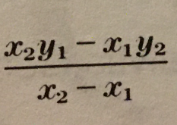
b =

where (x₁, y₁) and (x₂, y₂ ) are the coordinates of two points.
The user enters the coordinates one by one in order, and the program should print the y intercept.
For example, if the user enters

Enter x1 : 2
Enter y1 : 10
Enter x2 : 6
Enter y2 : 110

The program prints
The y intercept is (0, -40)

